**Cool Roofs**

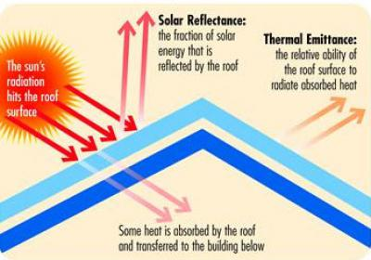

Solar reflectance and thermal emittance are the two radiative properties to consider when selecting a cool roof. (Image courtesy of the Cool Roof Rating Council)

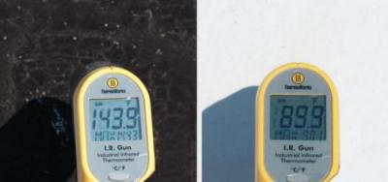

On a summer afternoon, the black roof at left was measured to be 30ºC (54ºF) warmer than the white roof at right. (Image courtesy of the U.S. Department of Energy)

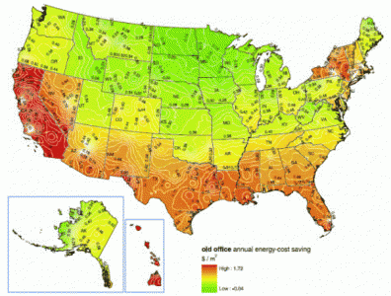

The winter heating penalty is outweighed by summer cooling savings of cool roofs in most of the U.S., except where the chart is bright green in the north. (Image courtesy of Heat Island Group, Lawrence Berkeley National Laboratory)

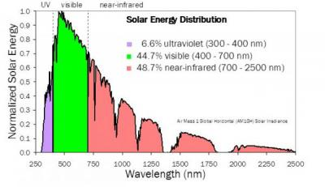

Nearly half of sunlight arrives as invisible “near-infrared” radiation. Cool-colored roofs are designed to reflect this invisible light. (Image courtesy of Heat Island Group, Lawrence Berkeley National Laboratory)

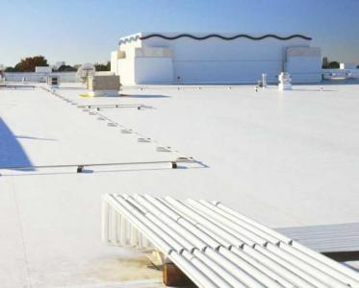

Single-ply membrane (Image courtesy of www.berwaldroofing.com)

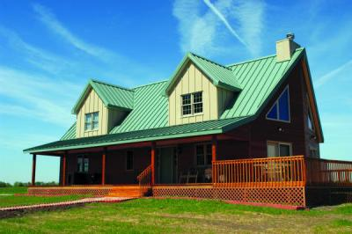

Metal roof (Image courtesy of CustomBilt)

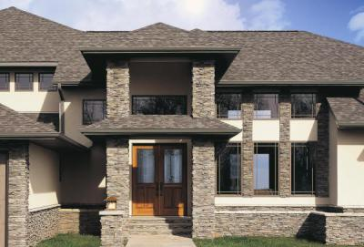

Asphalt shingle roof (Image courtesy of Certainteed)

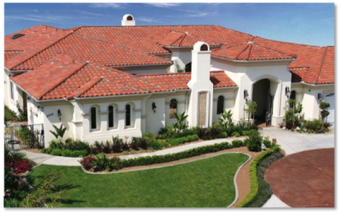

Clay tile roof (Image courtesy of MCA Tile)

**Definition**

A roof that strongly reflects sunlight can stay much cooler on a sunny day, than a roof that strongly absorbs sunlight. Another property that also keeps a surface cool is high [thermal emittance](https://heatisland.lbl.gov/glossary#Thermal_emittance). Thermal emittance is the efficiency with which a surface cools itself by emitting thermal infrared radiation. Thus a "cool" roof should have both high [solar reflectance](https://heatisland.lbl.gov/glossary#Solar_reflectance) (SR) and high thermal emittance (TE).

Since the spectrum of [thermal radiation](https://heatisland.lbl.gov/glossary#Thermal_radiation) does not overlap with that of solar radiation, thermal emittance is independent of solar reflectance. Therefore, we distinguish between the two when we define a [cool roof](https://heatisland.lbl.gov/glossary#Cool_roof).

**ADVANTAGES**

The substitution of a cool roof for a warm roof reduces [conduction](https://heatisland.lbl.gov/glossary#Conduction) of heat into the building, [convection](https://heatisland.lbl.gov/glossary#Convection) of heat into the outside air, and thermal radiation of heat into the atmosphere. This is a benefit for our buildings, cities and planet.

• Cooler outside air

• Fewer power plant emissions

• Better air quality

• Slowed climate change

• Energy and cost savings

• Reduced electrical grid strain

• Improved indoor comfort

**DISADVANTAGES**

There can also be undesirable effects for cool roofs. One example is the increased need for heating in winter because of cold climates. There is a limited amount of sunlight available to a roof.

**TECHNOLOGY**

**White Roofs**

White materials are a popular cool option for building surfaces that cannot be seen from the street, such as low-sloped „flat" roofs. Roofing products available in white include [single-ply membrane](https://heatisland.lbl.gov/glossary#Single-ply_membrane), [elastomeric coating](https://heatisland.lbl.gov/glossary#Elastomeric_coating), [painted metal](https://heatisland.lbl.gov/glossary#Painted_metal), tile, and [ballast](https://heatisland.lbl.gov/glossary#Ballast).

**Cool-Colored Roofs**

Cool-colored roofs are designed to increase reflection of sunshine while maintaining the color and aesthetic of traditional nonwhite roofing products. These include asphalt shingle, metal, tile, and ballast products. Cool color technology can also be used to create nonwhite materials for low-sloped roofs, such as membranes and coatings.

The text is based on the research from the Heat Island Group / Berkley Lab. You can find more information on the link below:

https://heatisland.lbl.gov/coolscience/cool-roofs